The Cascade USB data acquisition program has been written in Labview 2016 to communicate with a Hydrolab Quanta water quality sonde via a Waterlog H-4191 RS-232 to SD-12 interface and through a Measurement Computing USB Data Acquisition Device.

The main program uses a tab format to display multiple controls, indicators and graphs. The following screen shots display the front panel of the program and the tabs in order from left to right. Readings from the sonde and other readings from the pressure and flow sensors are displayed below the tab control in a “cluster indicator.” This indicator displays readings of the current head pressure, the current depth, and the cumulative volume, with the following readings from the sonde itself: the specific conductivity reading, the dissolved oxygen reading, the pH reading, the oxidation reduction potential (ORP), the temperature of the water, and the water salinity. Readings from the 3 auxiliary inputs to the USB DAQ are also shown. On the far right hand side, control buttons are shown. Below the control buttons, two indicator lights, one indicating the status of power and communications with the USB DAQ and one indicating the status of power and communications with the sonde are displayed. These buttons and indicators will be discussed further below.

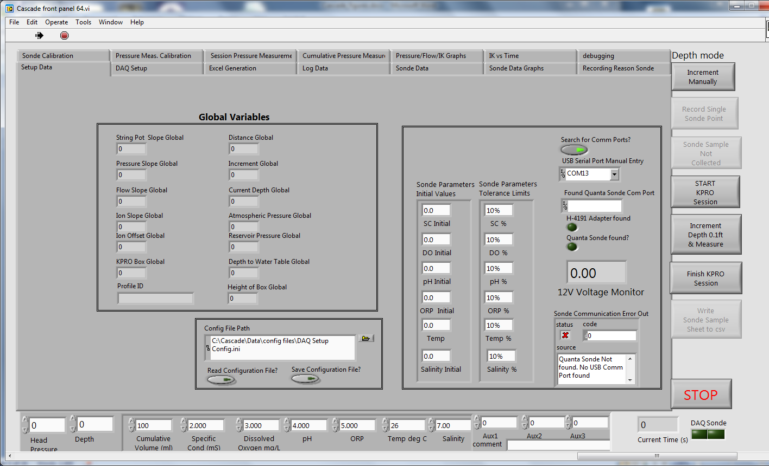

Figure : Setup Tab

1. The first tab is the “Setup Data” tab shown below in Figure 1; this tab has the controls for the main data directory for Excel Reports, the control for the Excel templates and the path to the template that is copied to the profile directory and then populated. Below those controls is the controls for the configuration file path and the usage of the configuration files.
   1. The configuration file settings will save out ***all*** the control settings and indicator settings in the program (all the tabs) into a configuration file. This occurs if the “Save Configuration File” button is set to on and the file is written during the exit routine when the “STOP” button is pressed.
   2. If the “Read Configuration File” button is set to on, then the configuration file location shown in the “Config File Path” is used as the source file to read all the control and indicator settings for the program.
   3. On the right hand side of the “Setup Data” tab are the controls and indicators for communicating with the sonde.
      1. The first control is the “Search for Comm Ports” control button. When this button is turned on, the program will automatically read all available serial communication ports on the computer to search for the proper response from the Waterlog H-4191 RS-232 to SD-12 interface. If the proper response is received, then the communication port is saved and displayed in the “Found Quanta Sonde Port” indicator. If the “Search for Comm Ports” button is turned off, then the serial port displayed in the “USB Serial Port Manual Entry” is used to communicate with the sonde.
      2. If the Waterlog H-4191 RS-232 to SD-12 interface has been properly found and communications have been established, then the “H-4191 Adapter Found” indicator light will be illuminated. (It is not illuminated on the example shown above in Figure 1.) The Waterlog H-4191 interface also reads and reports the 12V power supply input from the external power supply. This reading is shown in the “12V Voltage Monitor” numerical indicator. If this reading is greater than or equal to 11.75V, then the “Sonde” square indicator in the lower right hand corner of Figure 1 will be illuminated.
      3. If the H-4191 Adapter is found, then the program requests the ID string from the Quanda Sonde, if this is received correctly, then the “Quanta Sonde Found” indicator light will be illuminated.
      4. The last indicator on the “Setup Data” tab is the error indicator for communications with the H-4191 and the Quanta Sonde. For the case of the screen capture shown in Figure 1, the computer was not connected to the H-4191 adapter or the sonde, so the error message shown indicates that the “Quanta Sonde was not found and no USB serial ports were found,” and a red X is displayed in the status indicator. If communications were properly established, then the status indicator would have a green check and the error message would be blank.
      5. The “Sonde Parameters Initial Values” indicator shows the reference values that are used to calculate the percentage changes for each of the logged sonde values. This indicator will update to hold the last logged value, but the values shown here at the start are used to calculate the percentage changes for the first reading.
      6. The “Sonde Parameters Tolerance Limits” control cluster are used to calculate the percentage limits that is used to determine if a logged sonde reading is within tolerance. By default these are set to 10%.
   4. On the left hand side in the box labeled “Global Variables,” the various settings of the Global Variables used in the Cascade Labview program (in the project vi file named “Kpro Globals.vi”) are shown. These update on each loop of the consumer loop which updates the user interface and accepts commands from the producer loop which just waits for button presses or command entries.
2. The second tab is the “DAQ Setup Tab,” and is displayed in Figure 2. This tab has controls and indicators that deal with the setup and communincations with the Measurement Computing Corporation (MCC) Data Acquisition (DAQ) USB Model USB-2408-2AO, which is a 16 channel (single ended or 8 channel differential) data acquisition module with 2 analog outputs (AO). Setup and control of the MCC DAQ is accomplished through the Instacal program which can be accessed from the start menu and programs tab under “Measurement Computing.” The Instacal program is shown in Figure 3. If the MCC DAQ is found and properly identified, then the “PC Board List” will display the serial number and model number. Since the development computer was not attached to the Waterloo Water Sampling Module, the Instacal program displays the error message shown in the lower window in Figure 3. *The Labview program will not properly communicate the MCC DAQ if the Instacal program does not find the device. When first installing the MCC software and connecting a new MCC DAQ to a computer, the Instacal program will need to be run manually to find and identify the MCC DAQ device and create the CB.CFG file.* The device name of the USB device found in the Instacal CB.CFG file is shown in the “Device Name in Instacal” indicator.

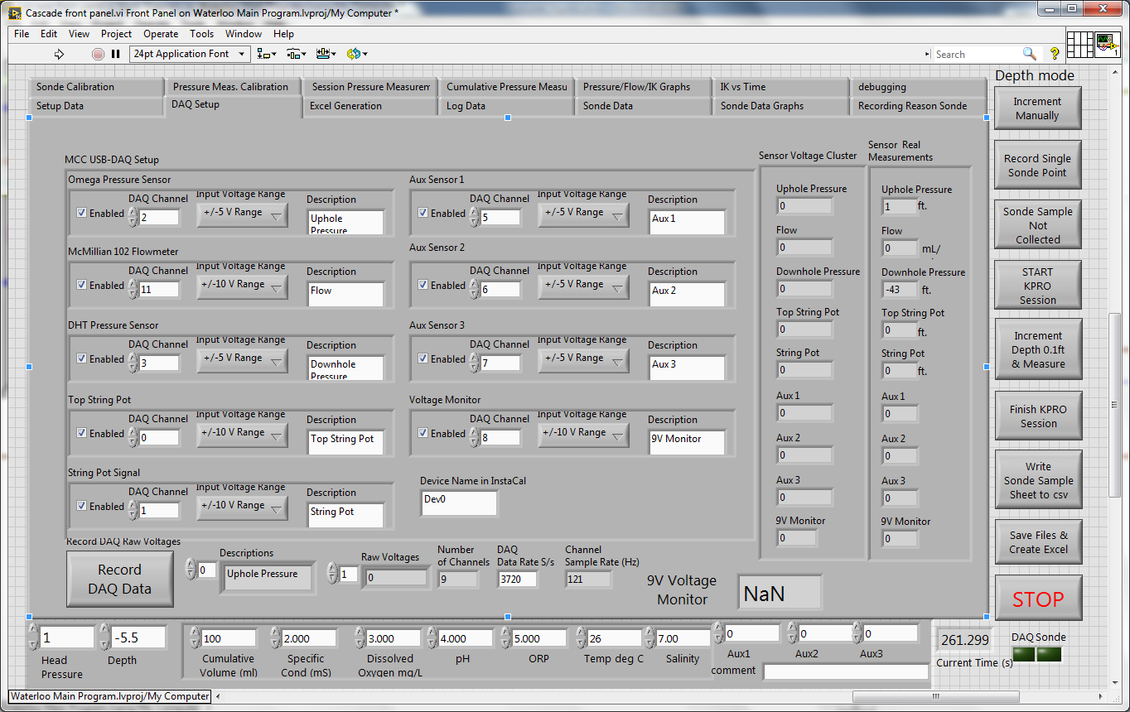

Figure : DAQ Setup Tab

The channel setup for the MCC DAQ occurs in the MCC USB-DAQ Setup Control Cluster shown on the left hand side of Figure 2. This control associates the readings from a specific DAQ channel with the physical measurement. It should not be necessary to change these values except to turn off unused sensors, if desired.

In the display shown above, Channel 2 is enabled (indicated by the check in the the Enabled check box) and is associated with the Uphole Pressure sensor, through the “Description” control. The voltage range for the input is the +/- 5V range. Similarly, Channel 11 is enabled and associated with the McMIllian Flow meter; as the maximum voltage output from the flow meter is 6V, the range for Channel 11 has been set to +/- 10V. Similarly, the controls for the rest of the channels and the association with physical parameters are shown for the rest of the control cluster. By default the range of the auxiliary channels is set to +/- 5V; this can be adjusted depending on the range of the sensor attached to the input. The Labview program reads the control to determine the number of enabled channels and displays the result in the “Number of Channels” indicator; in the above display it is 9, the number of enabled channels in the MCC USB-DAQ Setup Control Cluster. The “Descriptions” array also is filled with the descriptions of the enabled channels at the same time. The data acquisition rate each individual channel is determined by two parameters, the number of enabled channels and the board data acquisition rate, which is shown in the DAQ Data Rate s/S” as 3720 samples/second. (s/S). For each individual channel, the sample rate is shown in the “Channel Sample Rate Hz” indicator as 121 Hz, which is equal to (int(((DAQ Data Rate)-1+0.00064)*9)-1)-1.

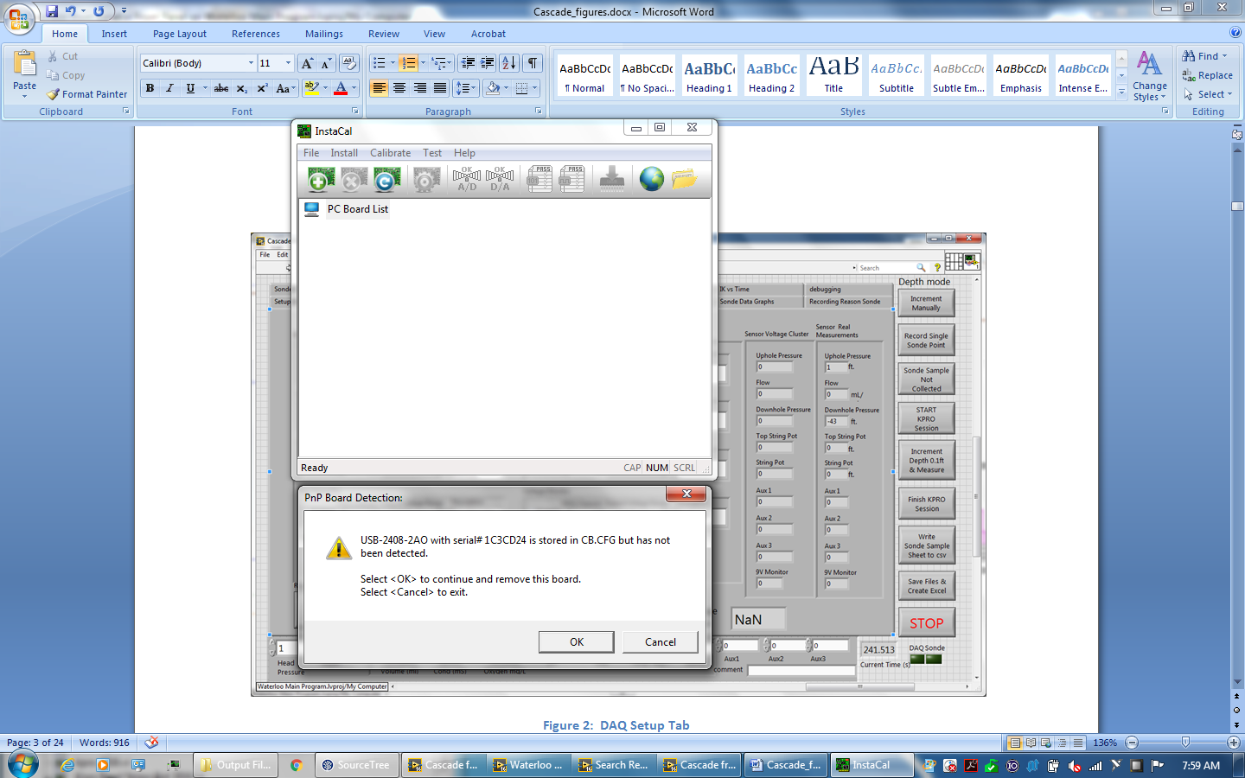

Figure : Instacal Program Window (top) and Error Warning (bottom)

As the maximum voltage range for the MCC DAQ is +/-10V, a small 9V DC/DC converter is used to generate 9V from the input 12V to supply voltage and current to the string pot. The 9V output is fed to channel 8 as the voltage monitor. The reading from this channel is displayed in the “9V Voltage Monitor Display” on this tab. A reading of 8.75V or greater on this monitor will also illuminate the DAQ LED indicator on the lower right hand side of the screen.

Pressing the “Record DAQ Data” button will result in an immediate reading of the inputs of the MCC DAQ which is displayed in the “Sensor Voltages Cluster” on the right hand side as ***raw voltages***. This set of indicators is also updated approximately every 100 ms. The readings displayed in the “Sensor Voltages Cluster” are converted to readings of physical parameters (by applying the slope and offset calibration values in the slopes csv file and the “Input Variables and Slopes” indicator from the Log Data tab (Figure 5 below)) and displayed in the “Sensor Real Measurements” cluster.

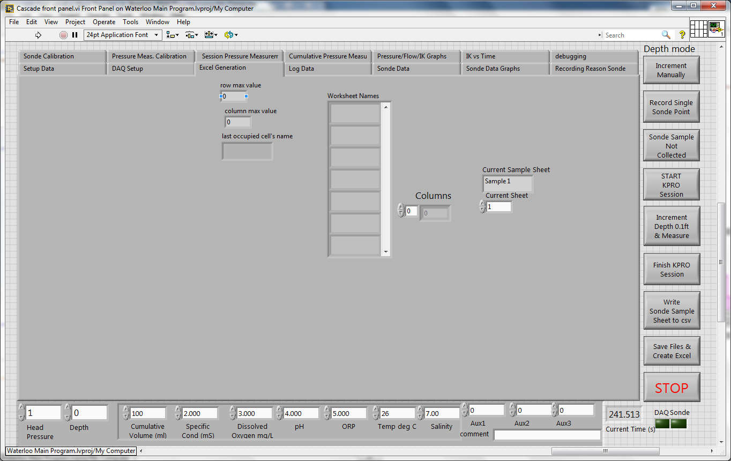

Figure : Excel Generation Tab

The next tab is the “Excel Generation” tab which displays the appropriate parameters from the Excel template file as to the number of worksheets, the names of the worksheets, the current active worksheet. This is displayed in Figure 4.

The excel worksheet header is shown on the “Log Data” tab which is shown on the left hand side of Figure 5. Some of these fields can be populated by the subsequent pop-up windows for Profile ID, KPRO Box serial number, and resevoir pressure. The rest can be entered here. The header values can be cleared by pressing the “Clear Groundwater Header Values” clear button, which is enabled when the program first runs. The sonde serial number will be populated automatically by interrogating the attached sonde for it’s serial number.

The Temporary Data Files Directory path control should be set to the default “C:\Cascade\Data\Output Files.” This setting is used to determine where the two sensor slopes files are located. The locations of these two files will be displayed on the right hand side of the tab in the “Slopes File Path” and ” Slopes History File Path” indicators. (The slopes csv file will also be copied to the directory created by the Profile ID entry, as discussed below.)

The profile ID setting in the worksheet header is read in from a pop-up window as shown in Figure 6. This entry should not contain any special characters such as tabs or carriage return/line feeds or new lines. The profile ID is also used to create a directory in the folder indicated in the Temporary Data Files Directory Path indicator if one does not exist. The profile ID is also used as a prefix on all the csv files and the excel file. In the example shown in Figure 5, the profile ID is “ara-5” and the created directory is shown in the “Output File Path” indicator. The appended path indicator shows the Output File Path with the profile-ID as the prefix. The remaining path indicators are built from the “appended path” indicator to generate the appropriate csv files and the xlsx excel file. Note: the string box is for a single line and will strip out the newline (carriage return and line feed ASCII characters).

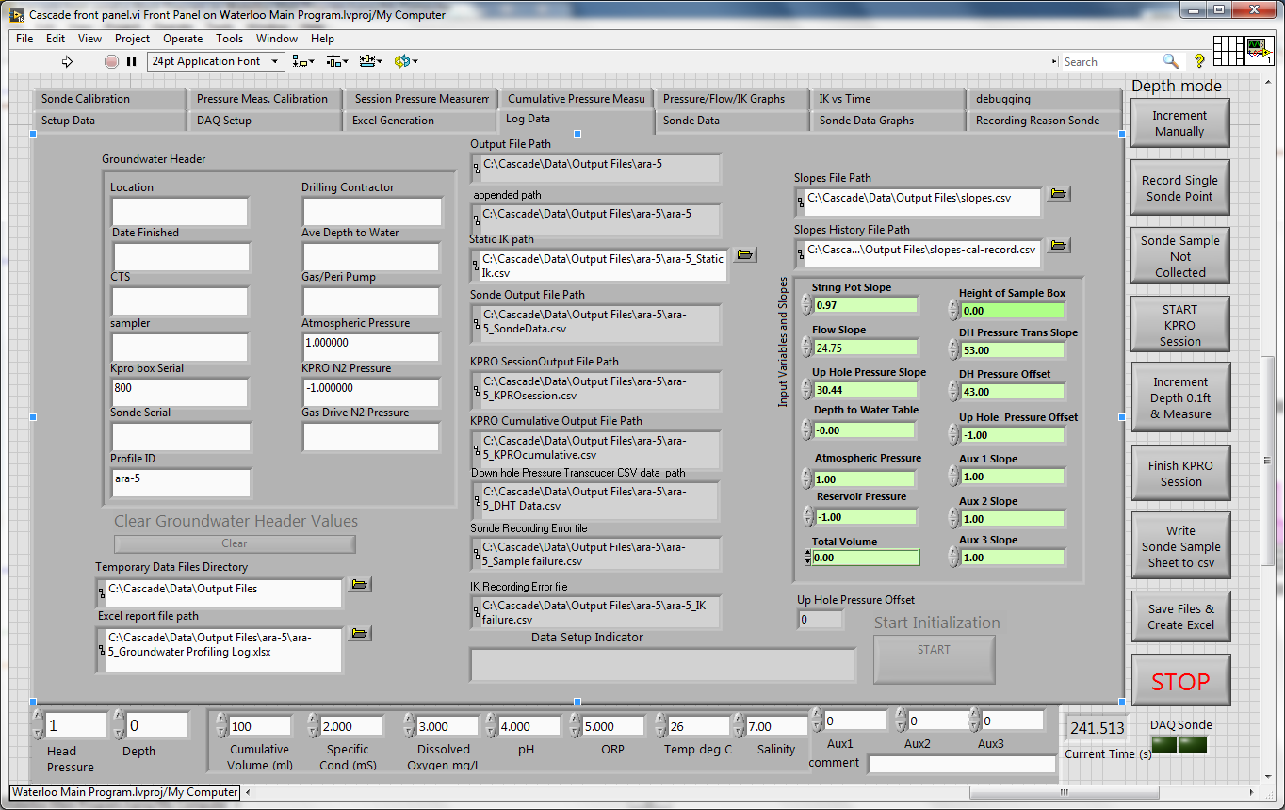

Figure : Log Data Tab

The “Data Setup Indicator” indicator and the Start Initialization Button will be discussed later, when discussing running the program.

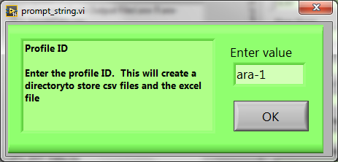

Figure : Profile ID Popup

The” Input Variables and Slopes” cluster of input variables shows the result of reading the slopes calibration file. The slopes variables and offsets are populated as part of the initialization process immediately following the File Dialog popup. The “Depth to Water Table,” “Atmospheric Pressure,” ” Reservoir Pressure,” and “Height of Sample Box” indicators will be populated by the appropriate pop-ups, discussed in the program operation section later. The default settings for the auxiliary inputs are 1.00 but can be changed in either this cluster or in the calibration popup if required.

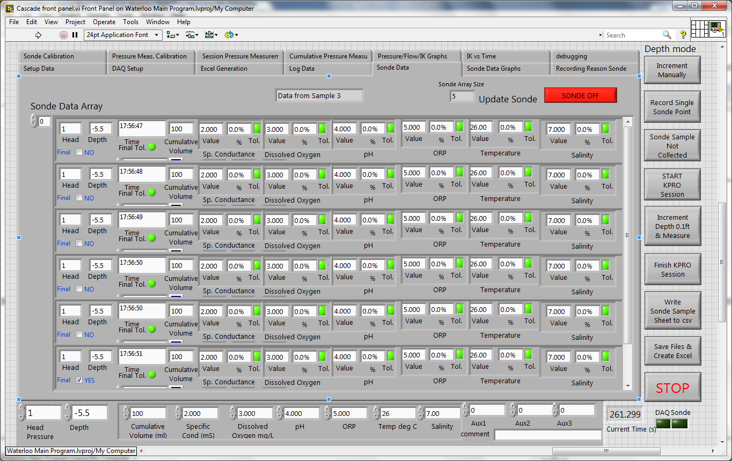

Figure : Sonde Data Tab

The next tab is the “Sonde Data” tab. The main indicator on this page displays the logged measurements from the sonde (up to six entries in the array), as well as the head pressure, the depth, the time, the cumulative volume and the readings from the auxiliary sensors. Also shown for each sonde parameter is the percentage change from the stored initial sonde parameter value from the reference values as indicated on the Setup Data tab (Figure 1). The default parameters are used for the first percentage calculations; following that, the reference values are updated to store the previous logged sonde measurement. If the percentage change from one reading to another for an individual sonde parameter measurement is below the limits shown in the “Sonde Parameters Tolerance Limits” control on the Setup Data tab (Figure 1), (default 10%) then the tolerance (“Tol.”) indicator will illuminate. If all the tolerance indicators are illuminated, then the “final tolerance” indicator will also illuminate. The text indicator on the top center indicates to which sample set the parameter readings belong; in the case shown in Figure 7 it is for sample set 3. The scroll bar to the right can be slide down in case the display does not show all the sonde data.

In the upper left, the red ”Sonde Off” button can be hit to turn green and display “Reading Sonde,” to repeatedly read the values from the Sonde that will be displayed on the indicator cluster on the very bottom of the front panel screen. These indicators are shown independently of the tab settings. Once they are stable, then pressing the “Record Single Sonde Point” button will trigger an additional read from the Sonde and place it in the Sonde Data Array.

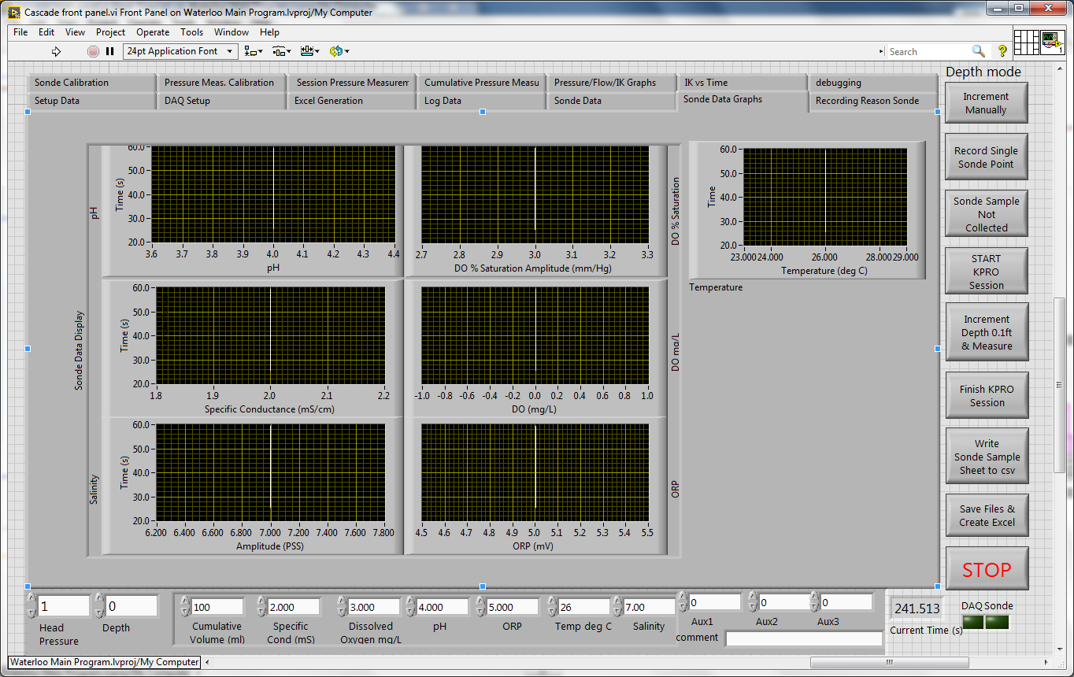

Figure : Sonde Data Graphs Tab

The next tab is the Sonde Data Graphs that graphs the data shown in the Sonde Data tab.

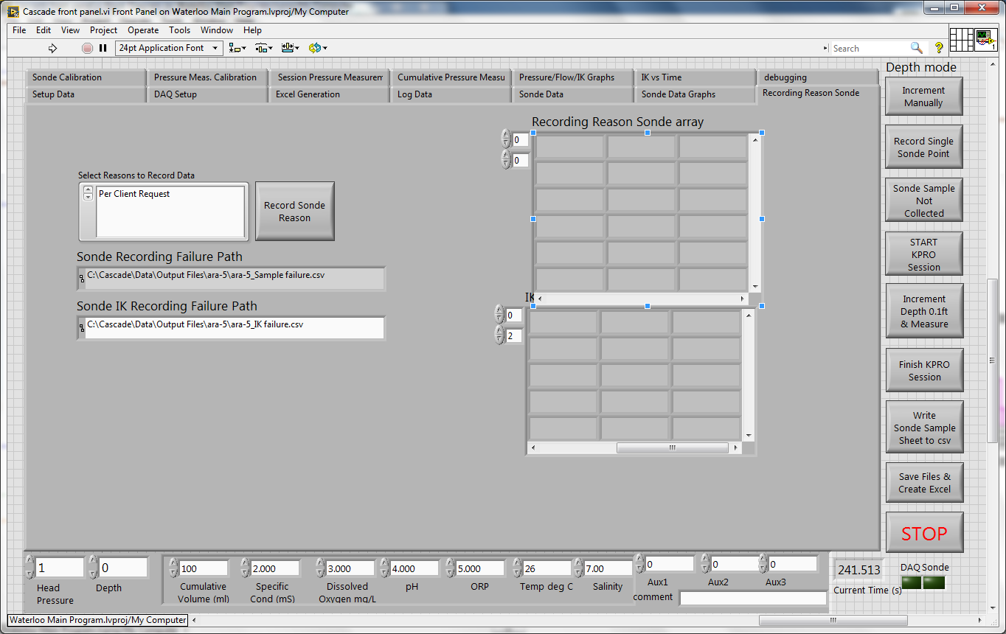

Figure : Recording Reason Sonde Tab

The next tab shows the entries for recording reasons why a Sonde data point may not have been taken at a depth. The “Record Sonde Reason” button will record the time, pressure, depth, and reason. The exact reason can be selected from the list on the left to the sonde button. Pressing the button will record the data in the csv file shown in the “Sonde Recording Failure Path” indicator. The array indicators to the right will show any previous reasons that have been recorded for the current profile. Also shown on this tab is an array of the reasons why a hydraulic conductivity (IK) reading may also be invalid and the path to the csv file in the “Sonde IK Recording Failure Path” indicator. The button and list to actually record an IK failure are shown on the Pressure/Flow/IK Graphs Tab tab (Figure 14).

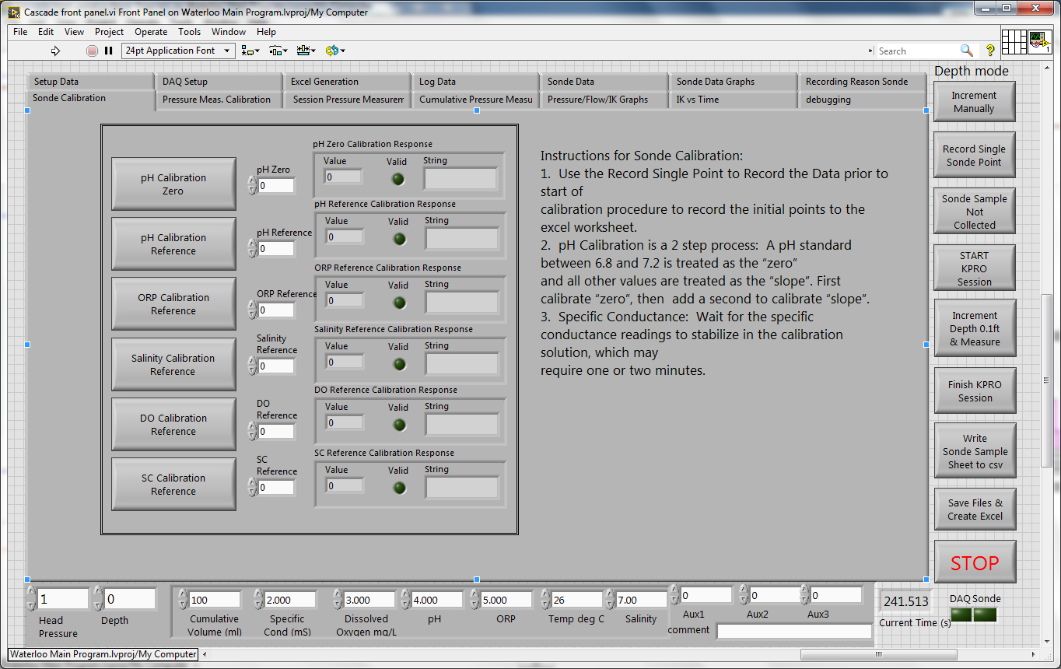

Figure : Sonde Calibration Tab

This next tab is to calibrate the Ott Sonde. The values of the calibration standards are entered in the white background numerical controls. Pressing the button to the left of the control will send the value to the Sonde. The return string from the Sonde is parsed and the values displayed on the cluster of indicators to the right of the control and the buttons for each of the pH Zero, pH Reference, ORP Reference, Salinity Reference, DO Reference and SC Reference.

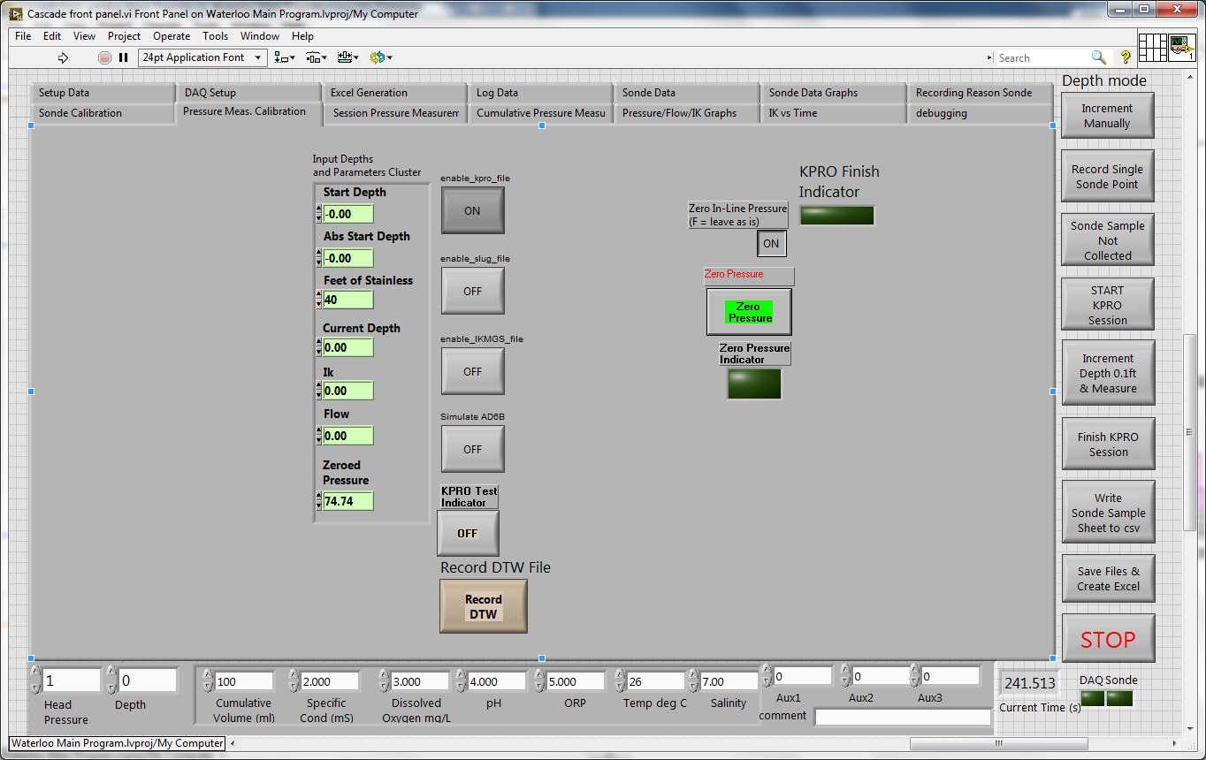

Figure : Pressure Measurement Tab

The next tab the “Pressure Measurement Calibration” shows controls and indicators that were carried over from the original Labview 6 KPro program. The “Input Depths and Parameters” cluster records the start depth, absolute start depth, current depth, IK value and the zeroed Pressure value. Most of the values displayed here have been shown on other tabs for easier control. The DTW button is to record the down hole pressure sensor in a separate csv file.

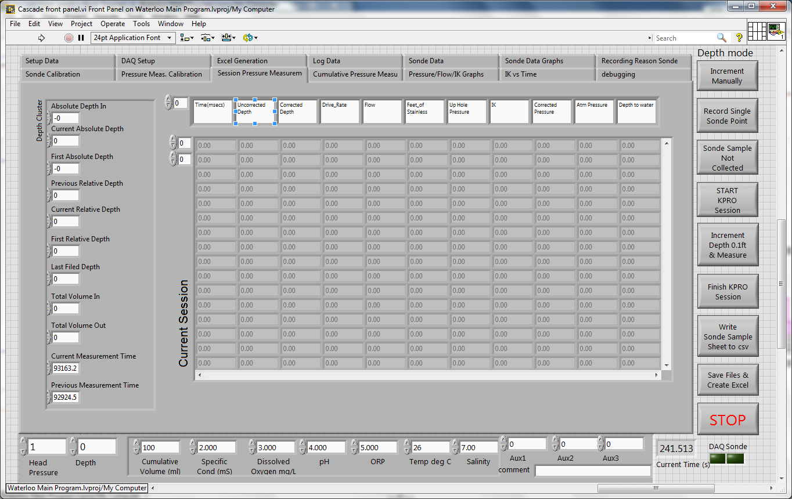

Figure : Session Pressure Measurement Tab

The Session Pressure Measurement Tab shows the values recorded at an appropriate depth if using the string pot or during manual increments by pressing the “Increment Depth by 0.1ft & Measure” button. Also shown on the left hand side is the depth cluster of indicators for the Absolute Depth measured when the “Start KPRO Session” button is pressed, the current absolute depth, the first absolute depth recorded, the previous relative depth, the current relative depth, the first relative depth, the last filed depth, the total volume in and out, the current measurement time and the previous measurement time. There are two array controls for the data array. Changing the top control (Row) for the data array will shift the rows up and down on the display in case more data points are acquired 16 rows on the display. Changing the bottom control (Column) shifts the display left and right, showing columns not shown on either the left or the right. Also shown is a column header display with a single array control. The header display is linked to the bottom Column control for the data array indicator, so that shifting the data array will automatically shift the headers in sync with the data array. Shifting the horizontal scroll bar will also shift the columns. Shifting the vertical scroll bar will shift the displayed rows up and down. When the program first starts, the data array is initialized with zeros and is greyed out as inactive. As a data point is acquired, the row will be active and will no longer be greyed out.

For this tab, a “session” is defined as the time and data acquired between a press of the “Start KPRO Session” and the press of the “Stop KPRO Session.” A press of the “Start KPRO Session” for sessions after the first, ie after the array has been populated with data, will copy the data to the “Cumulative Data Array” shown on the next tab, re-initialize the array back to zero and grey it out again. Pressing the “Finish KPRO Session” will write out the data shown here in this array to the csv file shown on the “KPRO Session csv file” indicator in Figure 5, the “Log Data” tab.

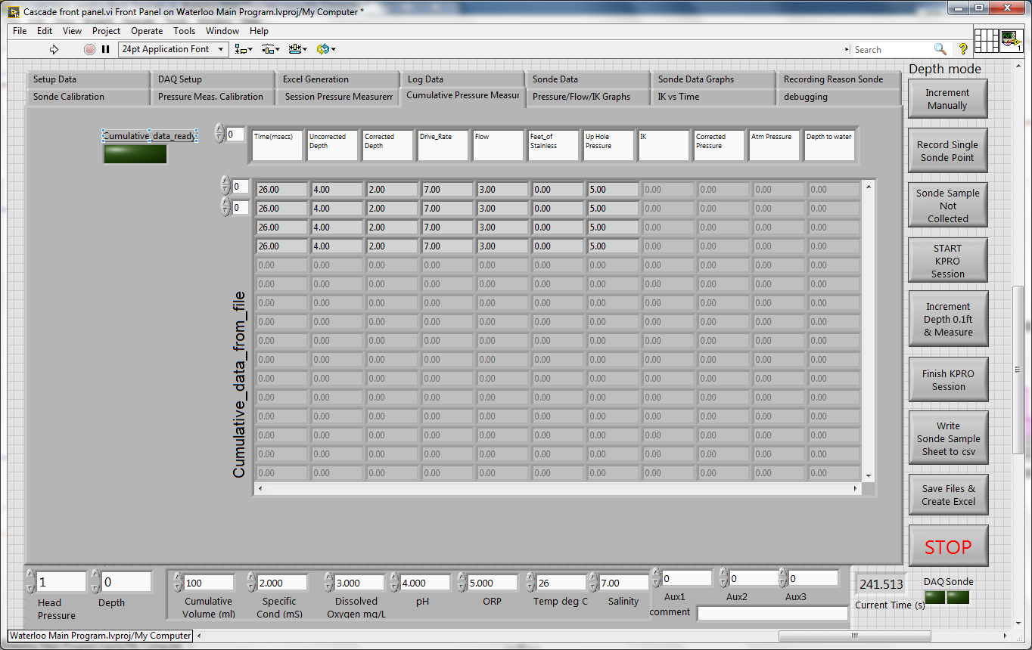

Figure : Cumulative Pressure Measurement Tab

The Cumulative Pressure Measurement Tab shows the values recorded at an appropriate depth if using the string pot or during manual increments from either a file or a previous session. Like the Session data array, there are two array controls for the data array. Changing the top control (Row) for the data array will shift the rows up and down on the display in case more data points are acquired 16 rows on the display. Changing the bottom control (Column) shifts the display left and right, showing columns not shown on either the left or the right. Also shown is a column header display with a single array control. The header display is linked to the bottom Column control for the data array indicator, so that shifting the data array will automatically shift the headers in sync with the data array. Shifting the horizontal scroll bar will also shift the columns. Shifting the vertical scroll bar will shift the displayed rows up and down. When the program first starts, the data array is initialized with zeros and is greyed out as inactive. As a data point is acquired, the row will be active and will no longer be greyed out.

This data array is populated when the “Start KPRO Session” button is pressed in the case of an existing file or if a data from a previous session has been recorded on the Session data display. Data is written to the csv file shown in the ” KPRO Cumulative Output File Path” indicator on Figure 5, the “Log Data” tab when the “Finish KPRO Session” button is pressed.

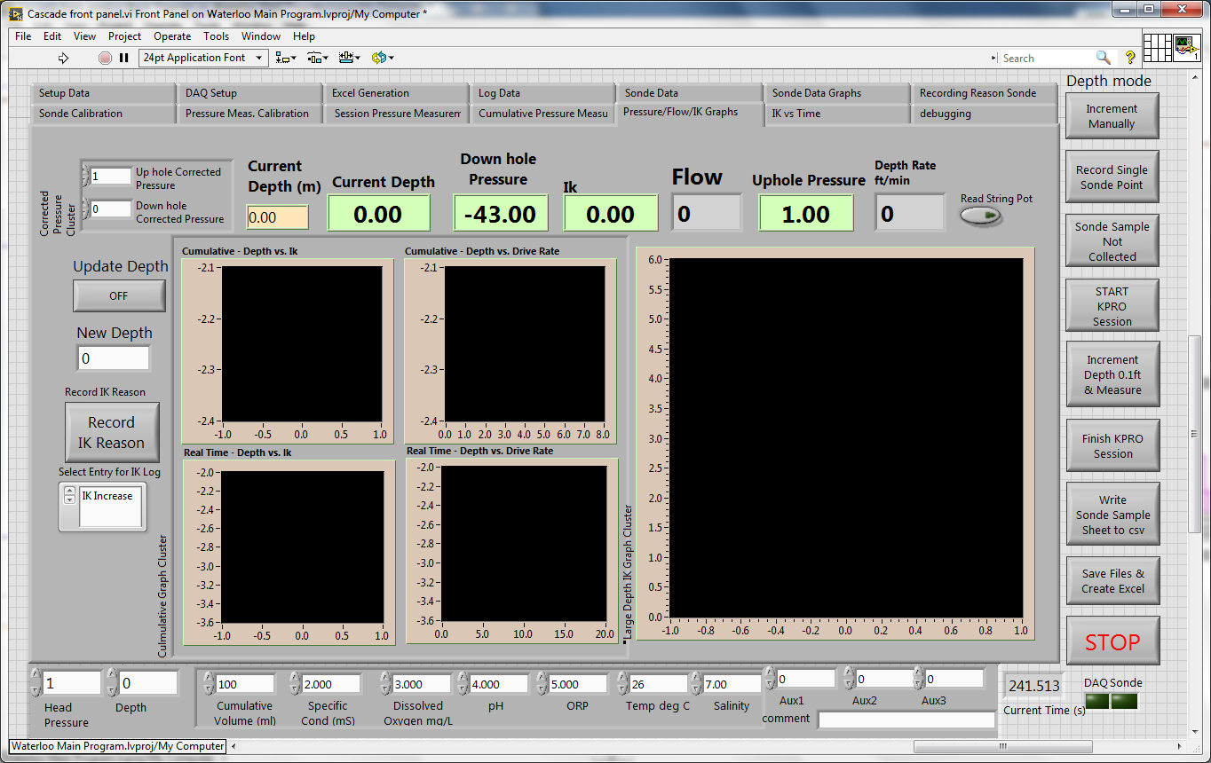

Figure : Pressure/Flow/IK Graphs Tab

The Pressure/Flow/IK Graph tab contains the graphs that show the IK as a function of depth for the data acquired during the session (plotting the data shown on the Session Pressure Measurements tab) and during the program operation (plotting the data shown on the Cumulative Pressure Measurements tab). At the left hand side, the “Corrected Pressure Cluster” shows both the up-hole Corrected Pressure Measurement and the Down-hole corrected pressure measurement. Below this is the “Update Depth” button that allows the depth to be corrected on this tab to the value entered in the “New Depth” control located just below the button. Below this is the “Record IK Reason” button and the Select Entry of IK Log” selection box that were discussed earlier for the “Recording Reason Sonde” tab Figure 9.

Across the top of the tab, the current depth is displayed in meters and feet, the down-hole pressure is displayed in ft of water, the up-hole pressure is displayed in ft of water, the Depth rate is displayed in ft/min, the flow is displayed in cubic ft/min, and the current IK is displayed, based on the current flow reading. At the far left the button “Read String Pot” is shown in the off position, it will be set to the on position if the far left button “Depth Mode” is set to “Read String Pot.”

The next tab “IK versus time” has a single graph that shows the history of the current IK readings over time to allow the user to see how the IK is changing as a function of time.

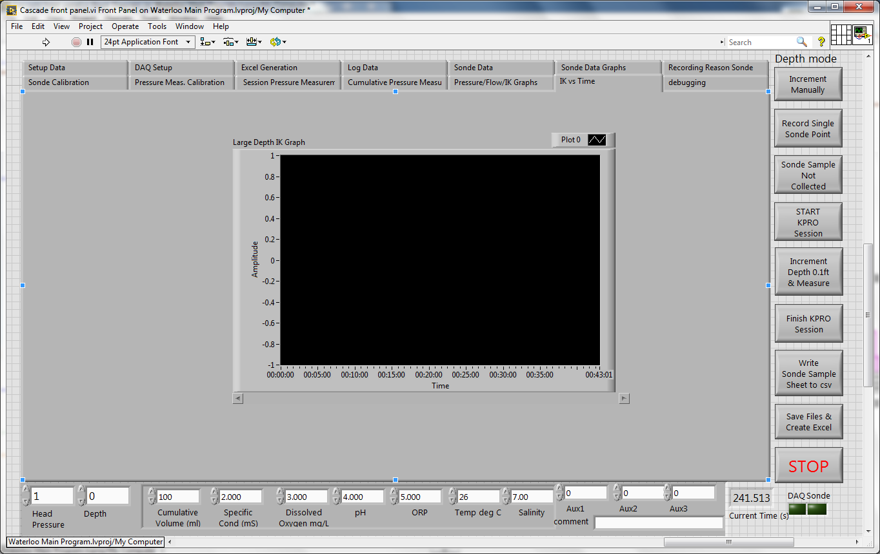

Figure : IK versus Time Graph Tab

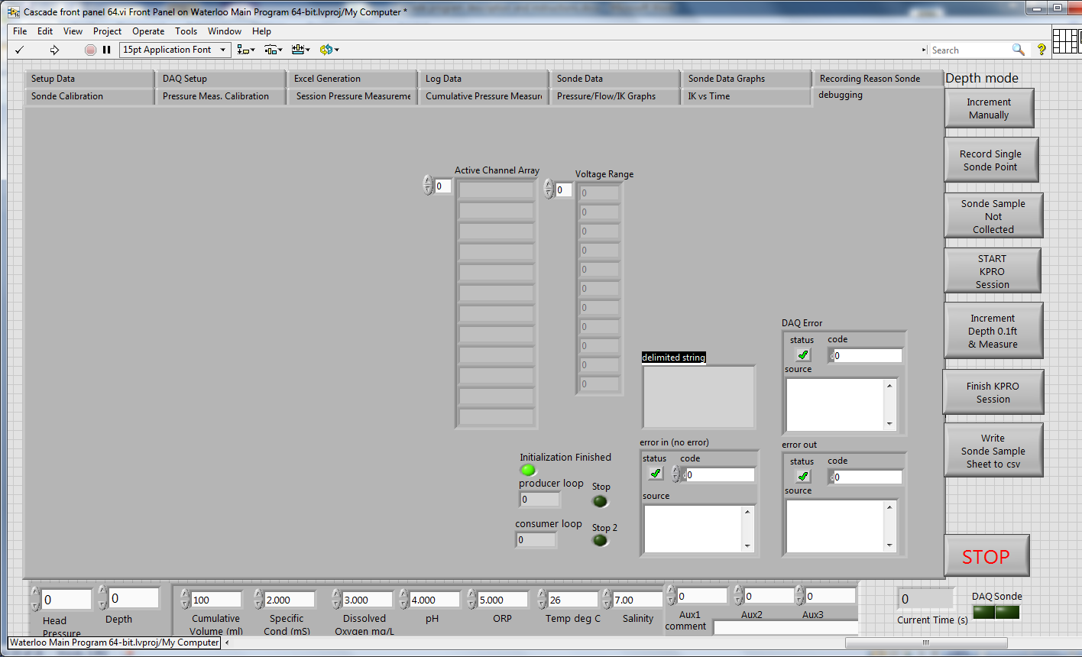

Figure : debugging Tab

The “Debugging Tab” is populated with indicators that will be used to debug the program in case of errors. Some of the Error indicators are shown on the right hand side of the tab. For example, as this screen capture was taken on a computer not connected to the USB DAQ, the “DAQ Error” indicator displays an error, with a code of 10001 that the DAQ could not create the appropriate tasks to measure a channel. The initial Error In and final Error Out are shown as well. The error indicator for the serial connection to the Sonde is shown earlier on the “Log Data” tab with the rest of the Sonde controls.

On the left hand side, an array of the active DAQ channels is shown indicating which channels have been set to ‘active’ on the ‘MCC USB-DAQ Setup’ control array on the DAQ Setup Tab shown in Figure 2. The array is concatenated to a single string to be sent to the USB DAQ unit; this is shown in the next indicator showing the delimited string. The settings for the voltage range for each channel is shown in the next indicator.

The program operates via two loops, a “producer loop” that monitors the button presses, interprets the state and sends commands to a second “consumer loop” that implements the commands from the producer loop. The loop indicators for each of the loops are shown at the bottom center of the tab; to indicate if the loops are running. The channel “queue” that sends the commands between the two loops also sends the ‘stop’ command triggered by pressing the ‘STOP’ button on the lower right hand side of the display. The actual stop commands that stop each of the loops will illuminate the ‘stop’ and ‘stop 2’ indicators also shown on the lower center. The final indicator on this tab is the ‘Initialization Finished’ indicator that indicated the initialization is finished. The need for this indicator has been superseded by the ‘Data Setup Indicator’ on the Log Data tab.

**Program Operation:**

When the Cascade.exe executable program is first run, the program will display the “Log Data” tab (Figure 17) and wait for the operator to enter the appropriate values in the ‘Groundwater Header’ control. The user need not enter the profile-id as that will be entered via a pop-up prompt. As discussed earlier, the Sonde Serial number will also be populated automatically if the program detects a sonde and proper communications have been established. The ‘Data Setup Indicator’ will alternate displaying ‘Hit the Start Key after Data Entry of Log Parameters and File Names ‘in red text and black text while the program is waiting for the operator to finish the data entry. The operator should hit the ‘Start Initialization’ when finished.

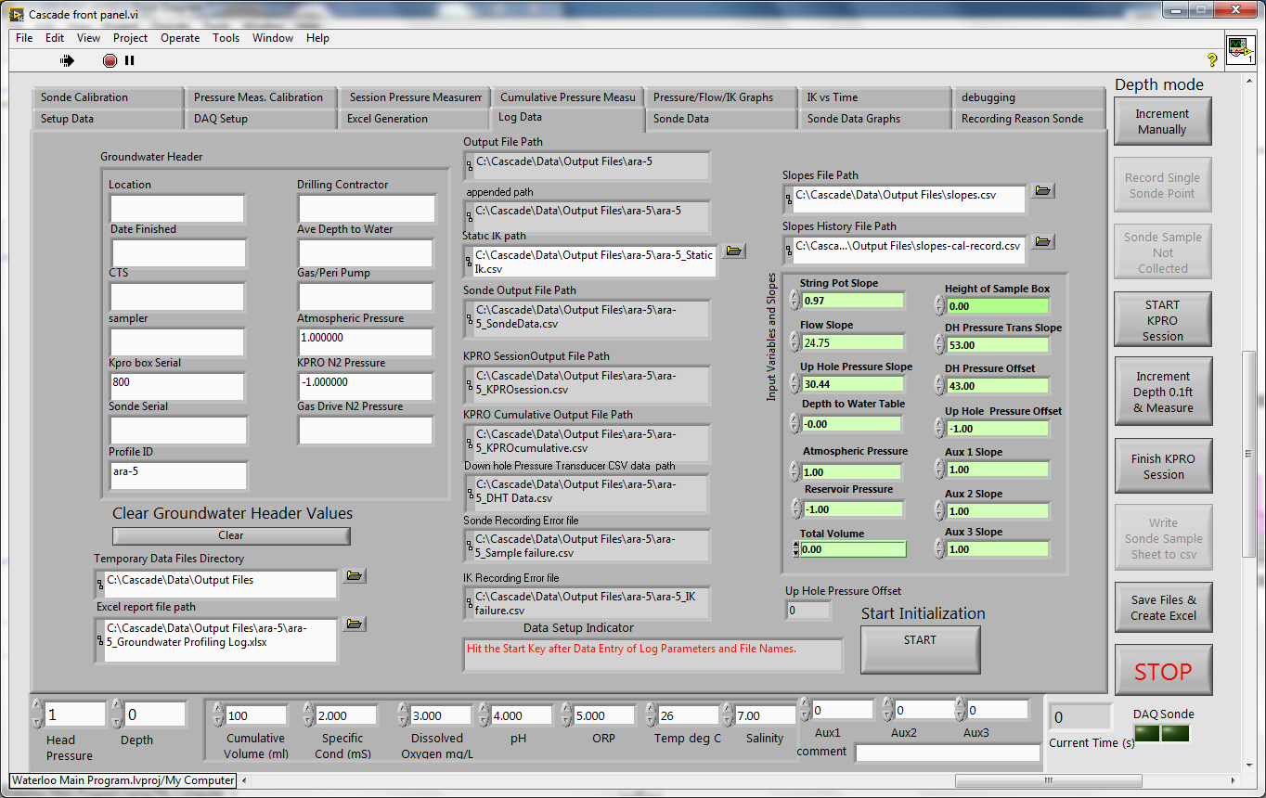

Figure : DAQ Setup Tab at Program Start

The output files folder where the output csv files and xls files for a test will be stored is shown below in Figure 18. This is the state of the folder when the main program starts.

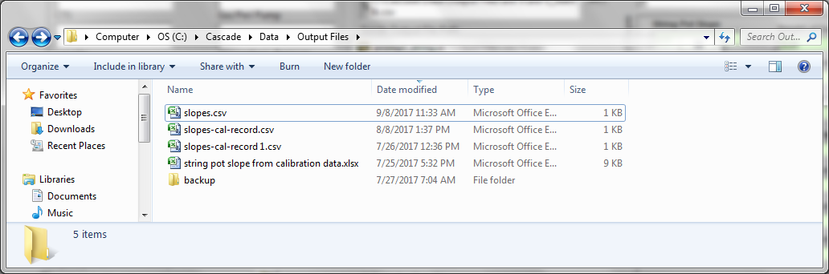

Figure : Output Files Directory prior to Profile ID popup

The first pop-up is shown in Figure 19 and is for the profile-ID.

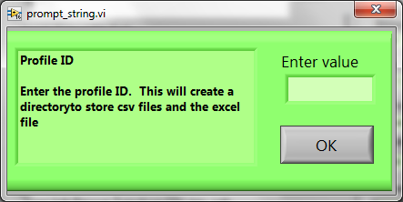

Figure : DAQ Setup Tab at Program Start

The ‘Profile ID’ pop-up will accept a text profile ID and create a folder in the above Output files directory with the same name. An example of a folder created with the Profile ID name ‘ara-1’ is shown below in Figure 20.

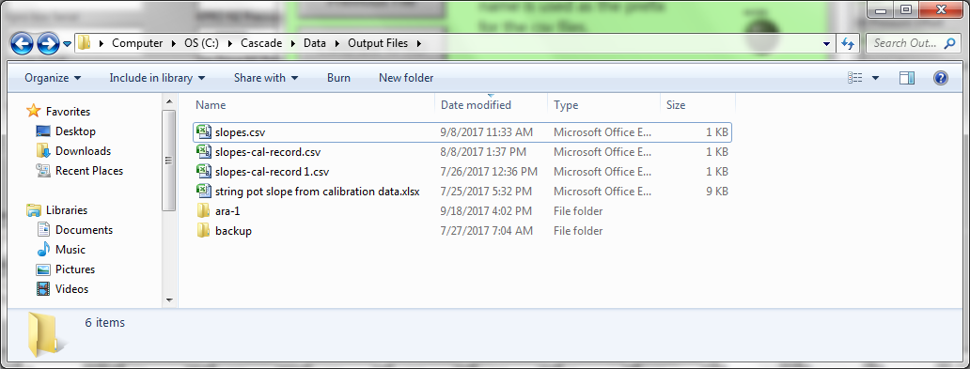

Figure : Output Files Directory after Profile ID popup showing the directory with the profile ID

The next pop-up is the ‘File Dialog’ popup, shown in Figure 21. This pop-up takes over as primary control of input/output from the keyboard and mouse clicks and effectively disables the main program from responding to mouse clicks. The loop counter shown down in the lower right indicates that the loop running in the ‘File Dialog’ pop-up is running as the loop counter increments.

There are three buttons on the left hand side of the ‘File Dialog’ popup window. The top button is for a ‘New File/Folder’ or directory. The middle button allows you to open a previously saved Cumulative Data.csv file to append new data to it. The bottom button starts the calibration process for the up-hole pressure sensor, the flowmeter, and the string pot. The calibration pop-up that opens also allows manual entry of the calibration for the down hole pressure sensor and the auxiliary sensors.

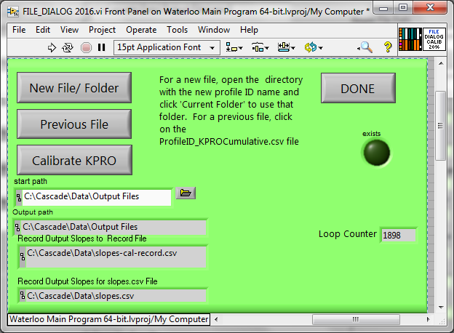

Figure : File Dialog Pop-up

The ‘New File/Folder’ button opens up a window explorer window as shown in Figure 22. In this case, it shows the ara-1 folder created when the profile ID was entered into the Profile ID pop-up. To update the Output path indicator to use this profile ID folder (‘ara-1’), you need to click on it in the explorer window, to descend down into the folder and then click on the ‘Current Folder’ button on the explorer window. This will set the path for the output file to use the ‘ara-1’ folder.

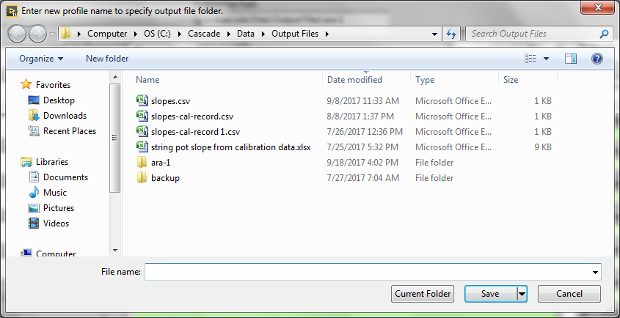

Figure : Output Files Directory after pressing the ‘New’ button on the Profile ID popup

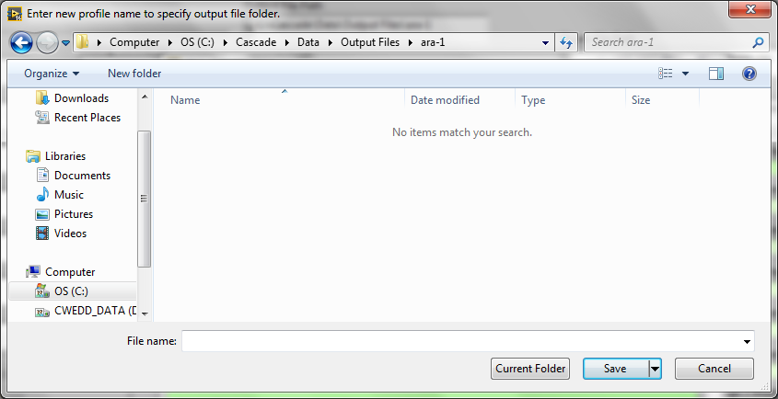

Figure : Output Files Directory after clicking on the Profile ID directory.

Click the Current Folder button to use the ara-1 directory. This will set the Output File Directory Path will be set to “C:\Cascade\Data\Output Files\ara-1” on the file dialog.

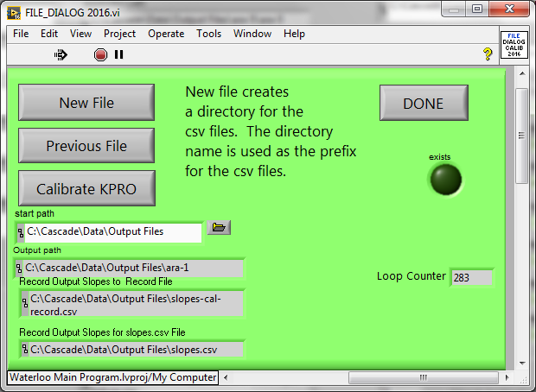

Figure : File Dialog Pop-up with updated Output Path Indicator

In the case where a previously created ProfileID_KPROCumulative.csv file will be used, click on the file and the data will be read into the program.

The ‘Calibrate KPRO’ button will open the ‘Calibrate 2016.vi’ as shown below in Figure 25.

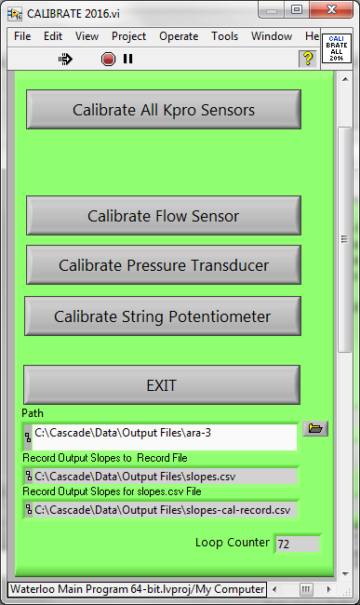

Figure : Calibrate Pressure Pop-up

Click on the ‘Calibrate Flow Sensor’ open the ‘Cal_FLOW_SENSOR 2016.vi’ as shown below in Figure 26. The reading from the flow meter is shown in the Flow indicator and the original global flow calibration slope is shown at the very bottom. The ‘Global Flow Slope Valid’ indicator illuminates when the global slope is in a valid range (not zero or infinity). The slope calculation routine has been modified to prevent division-by-zero which would result in a slope of infinity. Click start when starting the capture of 100ml in the graduated cylinder and stop when finished.

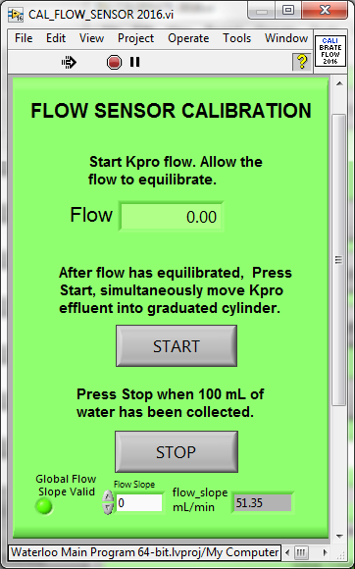

Figure : Flow Sensor Calibrate Pop-up

Hitting stop will display the calibration summary.vi, shown below in Figure 29. It will be discussed further later. Hit ‘OK’ to return to the ‘Calibrate 2016.vi’ as shown below in Figure 25.

Hitting the ‘Calibrate Pressure Transducer’ button will open the “CAL_PRESSURE_TRANSDUCER 2016.vi.” It also has a loop counter to indicate that it has control of the mouse/keyboard and is running. Following the procedure to zero the transducer and equilibrate the pressure reading. Clicking ‘OK’ will again will display the calibration summary.vi, shown below in Figure 29. It will be discussed further later. Hit ‘OK’ to return to the ‘Calibrate 2016.vi’ as shown below in Figure 25.

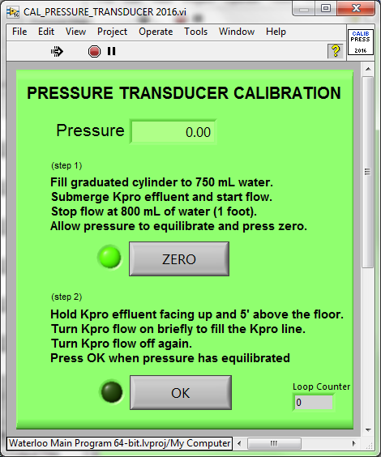

Figure : Pressure Sensor Calibrate Pop-up

Hitting the ‘Calibrate String Potentiometer’ button will open the “STRING_POT_CAL 2016.vi”, shown in Figure 28. Follow the procedure to calibrate the string pot by extending the string pot by the amount shown in the calibration distance (default 5ft) and pressing the ‘start’ button. Lower the string pot wire and press ‘stop’ when fully retracted. Clicking ‘stop’ will again will display the calibration summary.vi, shown below in Figure 29. It will be discussed further later. Hit ‘OK’ to return to the ‘Calibrate 2016.vi’ as shown below in Figure 25.

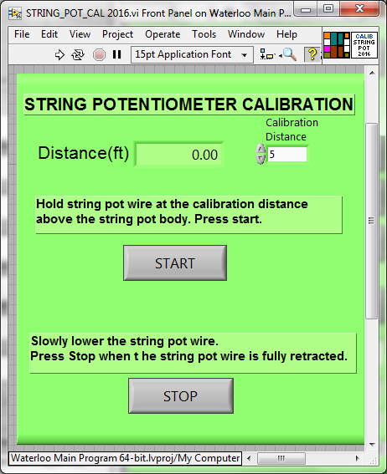

Figure : String Pot Calibrate Pop-up

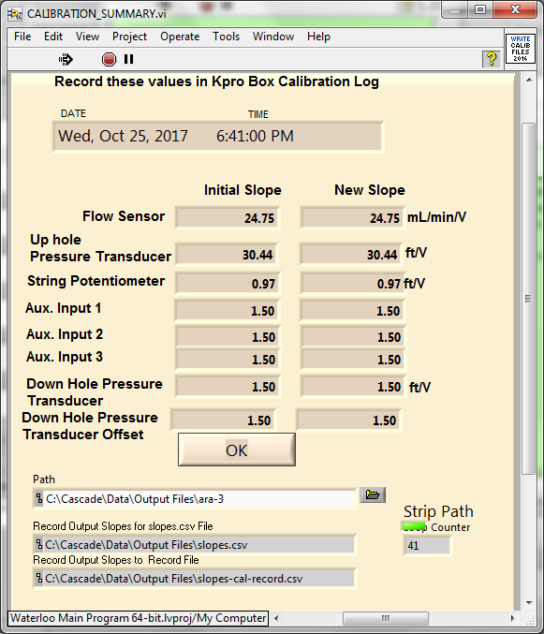

Figure : Calibration Summary Pop-up

The left column of the Calibration summary popup shows the original slopes, set from the global variables and read from the slopes file in the ‘C:\Cascade\Data\Output Files\slopes.csv’ file. The results from the recalibration is shown on the right hand column. Five additional fields have been added for the Auxiliary Inputs 1, 2, and 3 and the Down Hole Pressure Transducer slope and the Down Hole Pressure Transducer Offset. Click ‘OK’ to store the results to the slopes.csv file as a new row on the bottom of the file and as a new row in the slopes-cal-record.csv file and to return to the “File Dialog.vi” popup as shown in Figure 24. Click the ‘Done’ button to exit this popup.

Following the File Dialog.vi popup, the next popup is for the Up hole pressure calibration. Press the ‘OK’ button when the reading equilibrates.

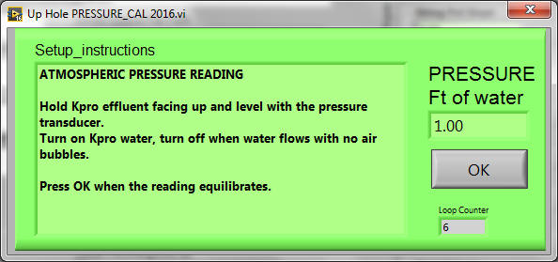

Figure : Atmospheric Pressure Pop-up

The next popup is to check the reservoir pressure. Again click ‘ok’ when the reading is equilibrated.

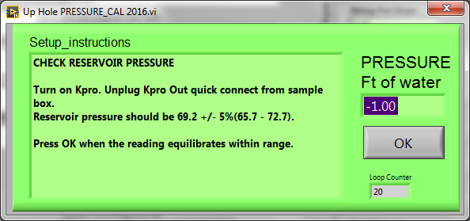

Figure : Resevoir Pressure Popup

The next popup is to enter the start depth. Again click ‘ok’ when entered.

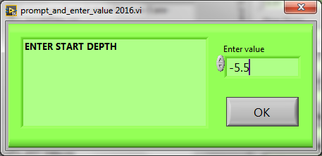

Figure : Start Depth Pop-up

The next popup is to enter the height. Again click ‘ok’ when entered.

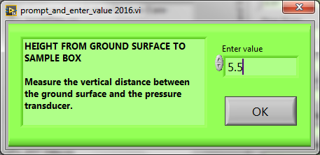

Figure : Sample Box Height Pop-up

The next popup is to enter the depth to the water table. Again click ‘ok’ when entered.

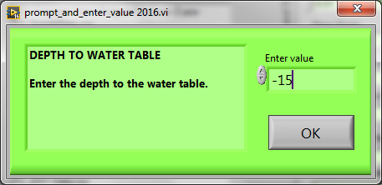

Figure : Depth to Water pop-up

The next popup is to enter the depth to the water table. Again click ‘ok’ when entered.

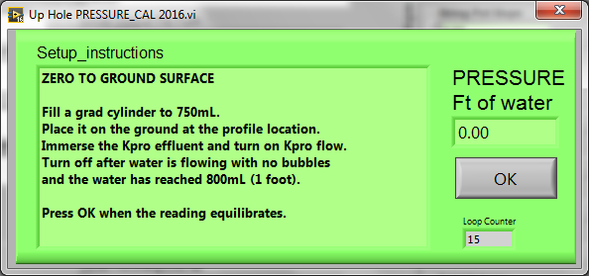

Figure : Zero to Ground Surface pop-up